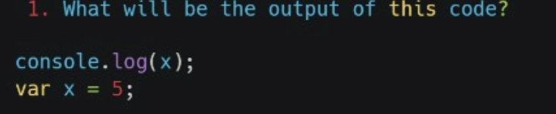

PS D:\23r\assest\html> cd html

PS D:\23r\assest\html\html> node js2.js

Undefined

In JavaScript, the var declaration is hoisted, meaning it is moved to the top of its scope.

1. The first console.log(x); outputs undefined because x is declared but not yet assigned a value.
2. After the declaration, var x = 5; assigns 5 to x, but this occurs after the first log.
3. Therefore, the output is just undefined.

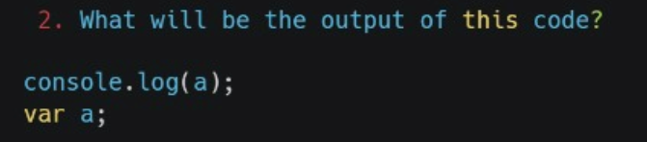

PS D:\23r\assest\html\html> node js2.js

Undefined

In JavaScript, variable declarations using var are hoisted to the top of their scope.

1. The var a; declaration is hoisted, meaning it's recognized before any code execution begins.
2. However, since a is not assigned a value, it defaults to undefined.
3. Therefore, when console.log(a); is executed, it outputs undefined.
4. The final output is simply undefined

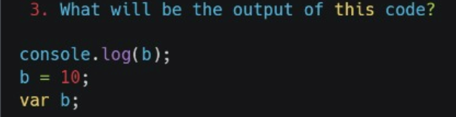

PS D:\23r\assest\html\html> node js2.js

Undefined

In JavaScript, the variable declaration with var is hoisted, but assignments are not.

1. The line console.log(b); attempts to log b before it has been declared or assigned a value.
2. At this point, b is undefined due to hoisting, so the output is undefined.
3. The assignment b = 10; occurs after the console.log, but it doesn’t affect the output.
4. Thus, the final output is undefined.

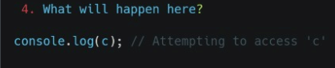

PS D:\23r\assest\html\html> node js2.js

Undefined

Exp: The output is undefined because the variable x is declared with var but not initialized before the console.log(x) statement. When JavaScript encounters the console.log, it finds that x has been declared (hoisted) but not yet assigned a value, resulting in undefined. Thus, undefined is printed to the console.

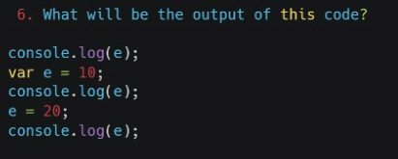

PS D:\23r\assest\html\html> node js2.js

Undefined

Exp : The first console.log(e) outputs undefined because e is hoisted but not yet assigned a value. The subsequent logs output 10 and 20 as e is assigned the values in those lines.

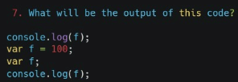

PS D:\23r\assest\html\html> node js2.js

Undefined

Exp The first `console.log(f)` outputs `undefined` because `f` is hoisted but not initialized before the log statement. The assignment `var = f = 100;` is a syntax error, so `f` remains uninitialized. The second `console.log(f)` would not execute due to the error, resulting in no output.

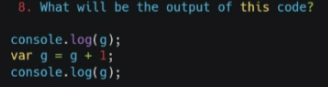

PS D:\23r\assest\html\html> node js2.js

undefined

The first `console.log(g)` outputs `undefined` because `g` is hoisted but not initialized when the log runs. The line `var g = g + 1;` attempts to reference `g` before it has a value, leading to `g` being treated as `undefined`. Thus, `g` becomes `undefined + 1`, which results in `NaN` (Not a Number). The second `console.log(g)` then outputs `NaN`.

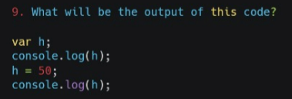

PS D:\23r\assest\html\html> node js2.js

Undefined

Exp The first `console.log(h)` outputs `undefined` because the variable `h` is declared but not initialized. At this point, it exists in memory but has no assigned value yet. When `h` is assigned `50` in the next line, it now holds a defined value. The second `console.log(h)` then outputs `50`, reflecting the assignment. This illustrates variable declaration and initialization in JavaScript.

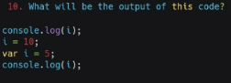

In JavaScript, variable declarations using `var` are hoisted to the top of their scope, but their assignments are not.

1. The first `console.log(i);` outputs `undefined` because `i` is declared but not yet assigned a value.

2. Next, `i` is assigned the value `10`, but this doesn't affect the hoisted declaration.

3. The line `var i = 5;` assigns `5` to `i`, but it's hoisted to the top of the function or global scope.

4. The second `console.log(i);` outputs `5`, reflecting the most recent assignment.

5. Thus, the final output is `undefined` followed by `5`.